TOUCH, HEAR AND SEA: A SIMULATOR FOR THE BLIND SAILOR’S GEOGRAPHICAL REPRESENTATION

Mathieu Simonnet¹, R. Daniel Jacobson², Jonathan Rowell³

- European Center for Virtual Reality, 25 rue Claude Chappe, 29280 Plouzané, France. E-mail: mathieu.simonnet@univ-brest.fr
- Department of Geography, University of Calgary, 2500 University Drive NW, Calgary, AB, T2N 1N4. E-mail: dan.jacobson@ucalgary.ca
- Anglia Ruskin University, East Road, Cambridge, CB1 1PT, UK, Email: j.rowell@anglia.ac.uk

Seatouch software and hardware aims at providing forblind people’s cartographic needs. Using haptic sensations, vocal announcements and realistic sounds, Seatouch allows blind sailors to prepare their maritime itineraries. Further than setting a route, Seatouch’s ambitions are to allow blind people to elaborate non visual map like representations (Figure 1)
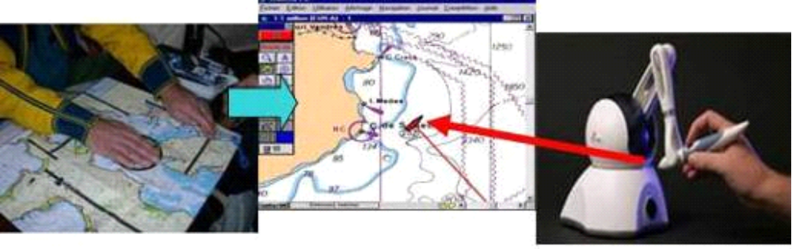
Figure 1: Seatouch environment: tactile map, digital map and haptic mouse interface
General description : In order to describe Seatouch utilization, it is separated into the six following modules: the map provider part, the haptic part, the sonification part, the vocal part, the simulation part and the NMEA part. All interaction commands are available in a vocal menu using the arrows, enter and backspace keys, or by keyboard shortcuts, and soon by vocal recognition using VOCON 3200 software.
The map provider module: Because the recent S57 vector maritime maps (Figure 2) enclose many geographic objects, we developed “Handinav” software (Figure 2). This transforms the new S57 data into XML structured files. Thus, an important quantity of objects can be chosen to be displayed or not: sea areas, coastlines, land areas, beacons, buoys, landmarks, and lot of other data are contained in these maritime XML maps. Seatouch software builds JAVA3D map from XML data. (Figue 3)

Figure 2: S57 vector maritime map and Handinav software: S57 to XML.
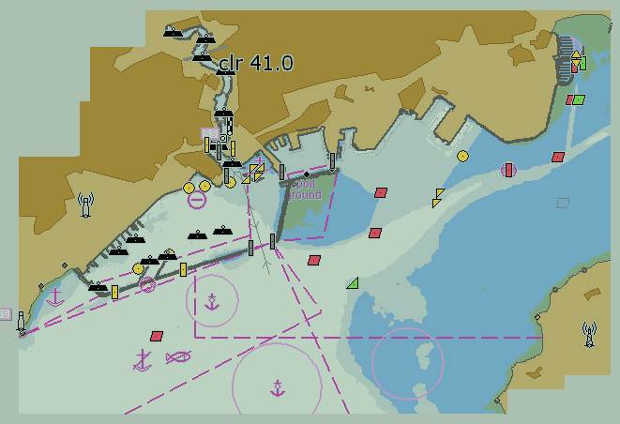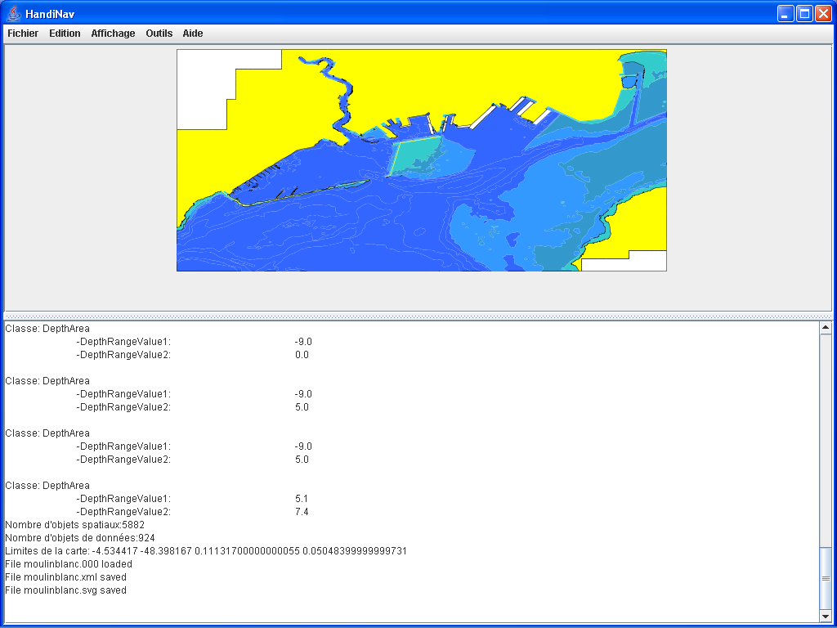

Figure 3: XML data source and Java 3D map reconstruction.
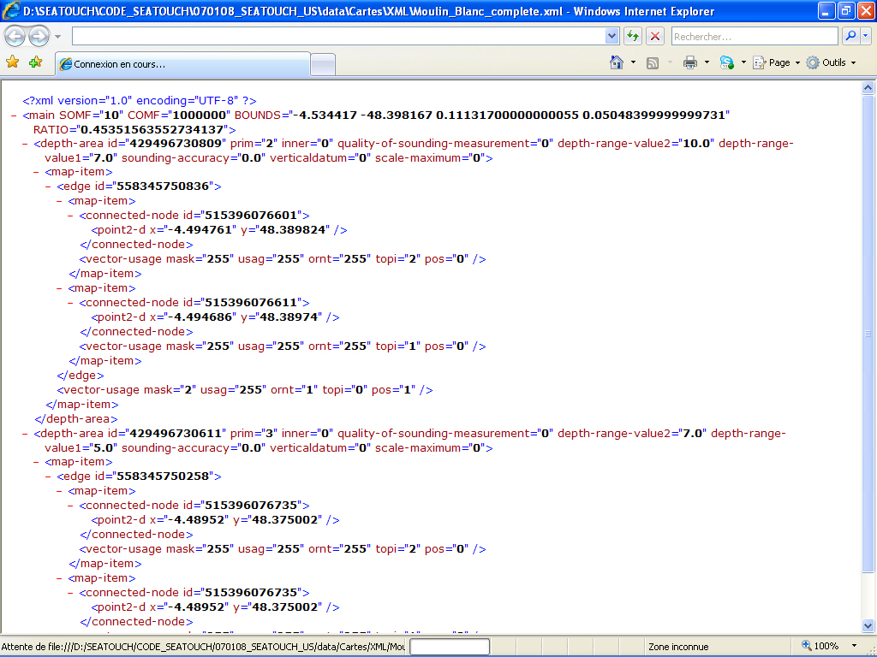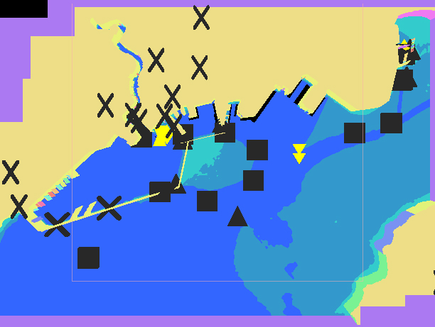
The simulation module: On these XML maps, the position of the boat can be chosen by entering coordinates in the simulator when started it (Figure 4). Then the weather conditions like the direction and the speed of the wind, the time relative to the tide and the speed of the simulation are modifiable. When stimulation is on, the speed of the boat results from the angle between the directions of the wind and the orientation of the boat. The values come from the measurement of the polar diagram of the speed of the 8 meters sailboat called Sirius. The user chooses the Sirius heading during the whole simulation with using the right and left arrows. When the boat hit the coast, besides the fact of a crash sound is played, the simulation stops.
The haptic module: Using phantom Omni haptic force feedback device, blind people explore a workspace of 16 centimetres wide, 12 centimetres high and 7 centimetres deep with a haptic cursor (see Figures 1 and 5). Thus, they touch different objects of maritime maps in a vertical plane in the same way as the sighted people view a computer screen. Nowadays, the haptic display is 2D-extruded. In other words, the relief of the land and depth of the ocean are drawn using only two flat surfaces separated by two centimeters. Between the land and sea areas, the coastlines form a perpendicular wall (analogous to a cliff face) that allows users to follow it with the phantom. The display of coastline uses the contact haptic force feedback.
Figure 4: The simulator

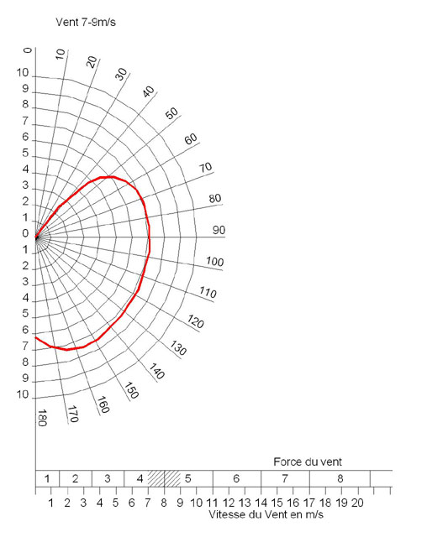
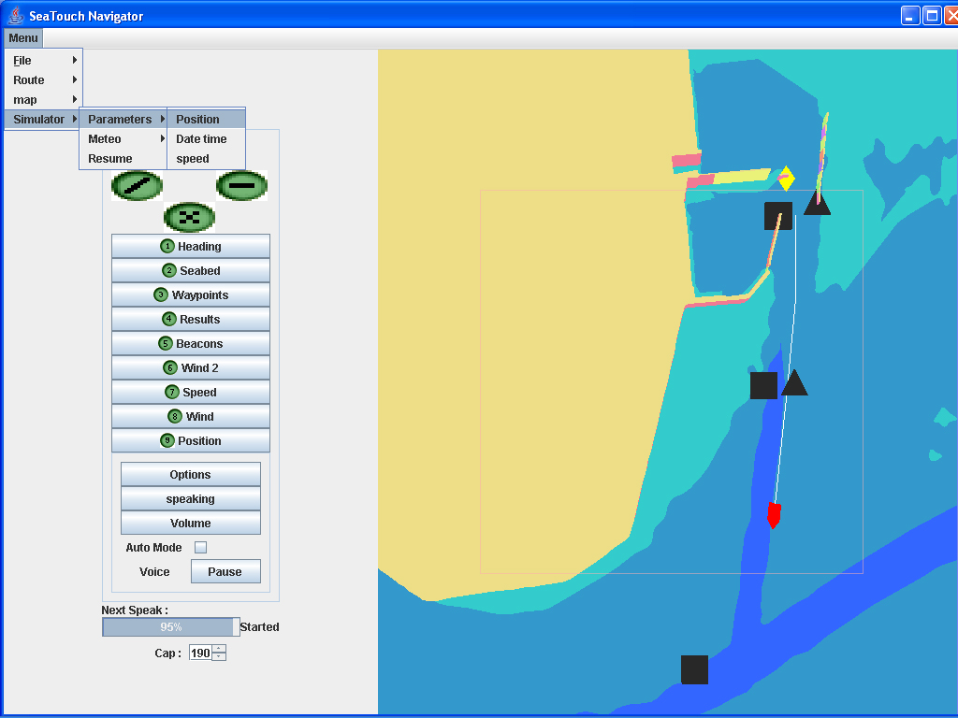
The Wind :
0°, 15 kts.
Speaking Simulator menu
Speaking permanent Heading control
Polar diagram

In contrast, for beacons, buoys and landmarks, we apply a constraint haptic force feedback to a spring of one centimeter diameter. This spring is an active force feedback field that maintains the cursor inside of the object with a 0.88 Newton force. In order to get outside of the spring, users have to apply a stronger force. Eventually, the display of the position of the boat uses the same spring but it can be navigated to by the users from everywhere in the workspace. To do this, they just click the first button of the phantom and the cursor catches up with the position of the boat. In The sonification module using the force feedback device, as soon as the users touch virtual geographic objects with the Haptic cursor, they can hear naturalistic recorded sounds relative to this object (Figure 5). Thus, when they touch the sea, the users can hear a water sound, when they touch and follow the coastlines, they can hear seabirds cry out; and when they touch the land areas, a sound of birds from the land is played. Moreover, if the users get push through the sea surface, they hear the sound that a diver would make and if the cursor is wandering in the air, a wind sound is played. Eventually, it is possible to touch the wake of the boat with hearing wash sounds or even to touch the viewfinder and to hear a sort of sonar sound. Here the redundancy between haptic and auditory stimulation extrapolates information and aim at making this virtual environment as intuitive as possible.
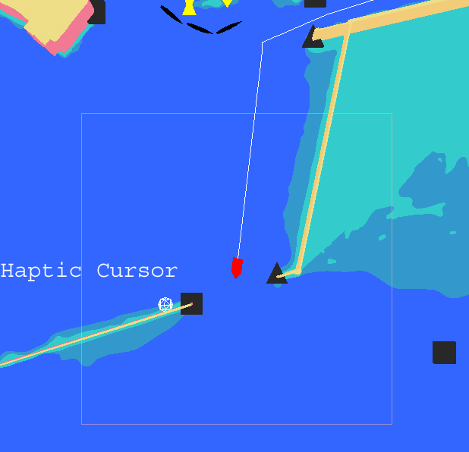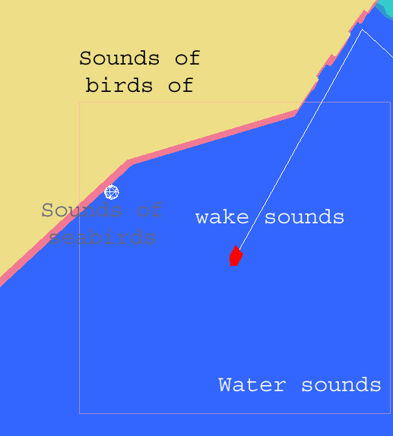
Sonar sounds
Figure 5: The haptic cursor and sonification environment

The vocal module
Using “Acapela” vocal synthesis, different information can be given by Seatouch. When the phantom cursor enters in a beacon, buoy or landmark field, the nature and the name of these are spoken. In another way, a user can ask for information about distance and direction. Before asking any information, user can choose the format of it. Thus, the distances can be announced in nautical miles, or kilometres, or even time if constant speed is five knots. About directions, they can be announced in cardinal (north, south…), numeric cardinal (0-360°), hours relative to the boat orientation (noon is in front of the boat and 6 o’clock is behind ) and also in port and starboard numeric relative to the boat orientation, for instance 90° on starboard is the same as 3 o’clock). The first two formats are given in an allocentric frame reference and the last two are egocentric. Otherwise, each information relative to the boat instruments is available in nine menus of four values each
The NMEA server module Seatouch Software can equally be connected to a Global Positioning System (GPS) using NMEA file format. NMEA is a universal protocol used in the transmission if GPS and maritime data developed by National Marine Electronics Association. In this case user can ask for instruments vocal values during navigation as the haptic feedback is quite hard to interpret when the sailboat is moving. Another possibility is to replay the NMEA file after the navigation. In this case, haptic, vocal and auditory elements are used by the blind sailor to understand their voyage. In order to provide blind people spatial tools that are as functional and as educative for their spatial needs, the mixing of the previous module have to be coherent on the one hand, and used in a efficient manner in the other hand. Consequently, several key research questions arise. - How the different components of Seatouch integrate with each other? - How the users are expected to interact with the software? How they do interact with it in a meaningful way? What are the optimal ways of presenting spatial information in similar multimodal interfaces?
Figure 6: The Vocal Interface Module
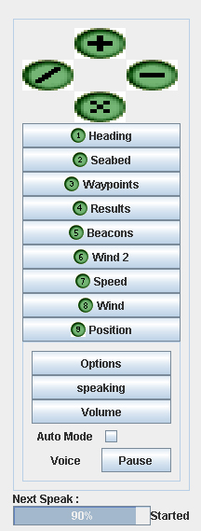
(1 )Heading menu: surface heading, ground heading, average surface heading and average ground heading;
(2) Seabed and stream menu: depth, nature of the seabed, stream speed and stream drift;
(3) Waypoints menu: bearing to waypoint, ground heading, distance to waypoint, speed to the waypoint.
(4) Results menu: max surface speed, average ground speed, time, distance covered on the ground and on the surface.
(5) Beacons menu: name of the nearest beacons, buoys or landmarks, bearing and distance from the boat, name of the second nearest beacons, buoys or landmarks, bearing and distance from the boat, name of the 3 nearest beacons, buoys or landmarks, bearing and distance from the boat, name of the furthest beacons, buoys or landmarks, bearing and distance from the boat.
(6) Wind menu number two: relative wind speed, relative
wind direction, max wind speed, VMG (Velocity make good);
(7) Speed menu: surface speed, ground speed, max surface speed and max ground speed;
(8) Wind menu: real wind speed: real wind direction on board, wind direction, max wind speed
(9) Position menu: latitude coordinates of the boat, longitude coordinates of the boat, latitude coordinates of the waypoint, longitude coordinates of the waypoint.
All these announcements can be automatically announced in respect of a difference thresholds that the user has set up. Seatouch software executes a check every 10 seconds.

Figure 7: Conceptual overview of Seatouch.
MARITIME MAP
BOAT DATA
SEATOUCH SOFTWARE
HAPTICS
VOCALS
USER SPATIAL REPRESENTATION
SONIFICATIONS

Utilization cases and interactions
All users are not equal in front of Seatouch software. Some of them appear to understand in an intuitive manner, while others express difficulties in learning and integrating information from the software. This is a reflection of widely fund individual differences. For the purpose of making this software more accessible, we describing it in details and emphasizing the different points which have to be revised in top priority. In order to describe Seatouch software utilization, we adopt a case study approach following a users navigation in a chronological order.
Figure 8: Seatouch is used in three different situations: before, during and after navigation.
User activity relative to the navigation
Before:
- Map Exploration.
-route settings.
-Simulation displacement.
- Route memorization

During:
- Boat direction.
- Vocal control.
- Position up dated.
- Event Adaptation.
After:
- Post simulation.
- Trajectories feed-backs collection.
- Link with physical environment.
Then
Then

Before the navigation, the user is expected to prepare his voyage. This operation tends to focus on the relevant parameters for the upcoming real navigation that includes details from one place to another one. Because the haptic device won’t be always be available during sailing on the physical sea, the user has to up date the position of the boat on a paper tactile map at the same time. In order to do this, we place the map on a magnetic piece of metal and we use a magnetic boat. Waypoints are indicated by magnetic buttons. The route is represented by an elastic band.
Map exploration Firstly, the user (or the coach) chooses the map where the ship will be sailing. He has to press enter key to enter in the main menu, “menu” is announced, then he presses down arrow to select the file menu, “file” is announced, then he presses down arrow until hearing “map shortcuts” and press enter, “map loading” is announced. When the map is loaded, a corresponding message is given. Seatouch opens a view centred in the middle of the map and set a “1 centimeter for one hundred meters scale” (1:10000). These verbal announcements are very similar to those from screen reader software.
Exploring the geographic space As seen in the previous part, the user touches the virtual map in a vertical plane. While moving the haptic cursor the blind participant feels and hears geographic objects simultaneously. This aims at providing a global and intuitive birds-eye like representation. The difficulty is to identify reference points in this “virtual” environment.
As different specific shapes can be recognized as landmarks, every beacon, buoy and lighthouse announce their name when being touched. In an alternative but parallel interface when pressing W and X keys, the user asks for longitude and latitude coordinates that can be useful to build points of reference and positioning the boat on the map.
Positioning the boat and setting weather conditions. Using simulator menu, the user can place their boat on the map by entering its coordinates and selecting the direction and the speed of the wind. In the same manner blind participants use keyboard and vocal synthesis feedback to set these parameters. If the user does not set any parameters, the boat will start in Brest Harbor (48°26N, 4°23W) in France with a north (0°) heading. The wind will also come from the north (0°) with a 15 knots speed. Thus when starting the simulation, the boat direction is in front of the wind. Consequently it does not move until the user change its heading. During the whole simulated navigation, the speed of the boat will respect the polar speed diagram.
View centering and scales changing Without sight, one of the most greatest difficulties with map interpretation comes from interpreting scale variation, or “zooming”. When the map is loaded and the boat is on it, user has to display an efficient view for its voyage. In other words, departure and arrival points have to be haptically accessible. B and N keys allow the user to zoom out and in. when changing scale, vocal synthesis announce the new scale. By default, the new view is centering in tne middle of the map, but the user can select boat centering view, or centering cursor view. These functions are accessible in the map menu or with the comma and doubt comma keys. Boat centering is interesting to find back the boat and to explore around. Cursor centering is better to discover different place far from the boat. Moreover, a view can be saved and restored. In order to save the current view, the user press K keys and confirm with L keys. Then, the user has to press the double doubt key to restore the view. This last function is essential to avoid the user getting lost. Eventually, an intuitive mean to explore the map is to grab and pull it. This can de done by pressing the click button number two of the haptic device and moving it in the workspace. When the user stop to press the button, the new view is displayed and “map moved” is announced. In this way, the scale does not change and the distance and the direction of the map displacement is known by the user because of their own movement.
Map distances and directions As sighted people use dividers on maritime maps, blind people benefit from a vocal equivalent in Seatouch software. When the user wants to know the distance and the direction between two geographic objects, they have to use the haptic device as a speaking divider. Thus, in contact with the chosen object, they create a first point by pressing the C button. After moving the cursor until being in contact with the other object, they press the same button again. Here the distance and the direction between these two points are announced in nautical miles and degrees relative to the north. However, the user can enter in the map menu and change the unities, distances in kilometers and direction in cardinal orientations as north, south, east, west… and so forth.
The boat ego-centred information Simulating a sailing navigation involves knowing permanently the position of the boat on the map. In this way Seatouch contains a haptic boat search function. When the user click on the first button of the haptic device, a spring is attracting the hand of the user, this allows blind people to find the boat and explore its close-by environment with the following function. The divider can also be used to measure distance and orientation to a point from the boat with pressing space bar. In this case, more different entities are available, in addition to the previous seen entity, information in a boat ego-centred frame of reference. Thus the clock unity will announce “noon” for an object in front of the user and “3 o’clock” for an object on the right. Moreover, if the user needs more precision the starboard-port numeric unity can announce “87° on starboard” for something somewhere in the right”. In another way the distance can be express in minutes in reference to a 5 knots speed, which is the average speed of the boat.
The route setting The functions that allow a user to create waypoints will be implemented soon. From all of this previous functionality, the user has been exploring the map and is now able to place different waypoints to mark his itinerary. An easy means to realize that is to fix departure point and the arrival point. Here, a line will be haptically drawn and will play a specific sound when being touched. The activity of the user consists of inserting a waypoint each time that this line encounters an obstacle. Each waypoint has to be named with the name of the obstacle in order to help blind people to build landmarks for the following voyage. The user can do these operations in the way point menu using keyboard and haptic device together.
When the different waypoints are created, the user has to save them in a route. Then the activation of the route will allow blind people to ask vocal information with a vocal waypoint menu. As described in the first part above, bearing to next waypoint, distance to waypoint and speed to the waypoint are available.
Simulating the voyage As soon as the user has achieved the setting of the waypoint, they are able to virtually cast of one’s mooring and to helm the boat step by step to reach the waypoints of the route. The convenience of this method attempts to make the user feel the features of the voyage in such a realistic way. The user will have to navigate with the difficulty of the wind effect. For instance, if the user has planed a path in a 0.1 nautical mille in front of the wind, there are many chances for him to run aground. If that happens, a loud sound of crash and Morse code emergency signal is played for 8 seconds. Without the vision, this moment is so sudden and unpleasant that the user is directly frightened. In other words, during the simulation the user feels the presence of the danger. However, it only virtual happens, that’s why the users can try complex itineraries and run aground as often as they please. This allows users to attempt and to become more familiar with complex voyages in the virtual environment, journeys that they may not attempt in the real maritime environment. The consequences that we expect with the simulation are that the user builds a functional representation of the maritime map in addition to the layout of the place.
Future Plans Currently there are no wind drift, neither interactions resulting from the stream of the tide, neither erratic wind in strength and directions. Thus, the simulation is easier than the real navigation. However, these interactions will be implemented and soon be available.
During navigation In order to control his trajectory on the sea, blind user needs the same Seatouch Software. However, before launching this latest, the NMEA server has to be on. It will send boat instruments information to the software instead of the simulation event. So here, position, state of the wind, depth, and magnetic information comes from the physical world. The sailor, after the simulation, has at one’s disposal a functional route. These successive waypoints will allow him to know where he is during the real displacement reminding to the virtual displacement. It is expected during this navigation the user put instead of his virtual representation a tangible representation made up of natural sensations like the feeling of the wind, the sounds of the coast and the interactions of the elements.
The boat direction Seatouch software is assists in preparing a navigator. In a crew, the navigator is usually in the boat cabin at the map table. He is a different person from the helmsman and the sails setters. The navigator has to think ahead about the appropriate heading to get there from here. If the crew wants to be efficient, the navigator must always tell it about the next heading and about the expected time to do it. Thus, using vocal information, the navigator aims at giving right directories to his crew at the appropriate moment.
The vocal control However because of the waves, the haptic device can not be used during sailing, only the magnetic tactile paper maps are available. According to that the navigator has to update his position during the whole navigation. The navigator or the crew can both ask for vocal information about navigation. Usually, the navigator asks the crew for a specific heading and set an auto mode for the vocal bearing and heading information. According to that, the software checks every ten seconds if the bearing and the heading are more different than the vocal threshold; in this case, vocal synthesis will announce the current heading and bearing. Usually we set a ten degrees threshold depending on how high are the waves. When the bearing to the next waypoint is in front of the wind or is less than 40°C far away from the source direction of the wind, following the waypoint is not possible. In this case, the crew will have to sail close to the wind and tack when the navigator will ask them for tacking. That means that the sailboat will do zigzag along the waypoint. However, this kind of trajectory demands a lot of space to reach the next point. Consequently, the navigator’s role is to choose the right side of the way to avoid obstacles as rocks, seawalls and beacons.
Position update and sudden event We can easily imagine that the wind can change in an unexpected direction and strength, or that a member of the crew can be sick or injure in an accident. In theses cases, it may be important to pull in at an harbour quickly. An autonomous spatial skill would be to be able to decide where to call at and the appropriate heading to reach it. This capacity requires mastering a mental representation of the surroundings and using the help of the updated position on the map. Here an appropriate heading as to be followed to reach this point without any waypoint. Being successful in such a spatial task shows the evidence of the construction of a cognitive map.
After navigation The debriefing consists in replay the NMEA file. This latest provides Seatouch all information of the different instruments. Pause and can simulation speed can be used. Moreover, the whole track points of the simulation can be displayed in a tangible way. Thus, when touching the track points line, the user feels a haptic line and hear the wash.
Debriefing provides virtual feedbacks of the real environment. This presents the convenient to confirm or correct mental representation. For example, if the navigator thinks that he was 0.5 nautical miles from the Brest bottleneck edge while he was 0.1, he will discover it and maybe on that occasion discover that the Brest bottleneck is not 2 nautical miles large but 1. When that happens, it should fixed up in memory because it is an life experience with all the feelings, the episodes and the meanings which composes it. Seatouch software debriefing aims at reminding these all feelings from the physical navigation to connect them to the structural representations of map. With many debriefings, we attempt that the user will improve to build link the functional and structural representation, consequently, the simulation would become more and more efficient.
References:
Golledge, R.G., Rice, M., and Jacobson, R.D. (2005) A Commentary on the Use of Touch for Accessing On-Screen Spatial Representations: The Process of Experiencing Haptic Maps and Graphics. The Professional Geographer, 57 (3). 339-349.
Kitchin, R.M. and Jacobson, R.D. (1997) Techniques to collect and analyze the cognitive map knowledge of people with visual impairments or blindness: Issues of validity. Journal of Visual Impairment and Blindness. July-August, 360-376.
Rice, M., Jacobson, R.D., Golledge, R.G., and Jones, D. (2005) Design Considerations for Haptic and Auditory Map Interfaces. Cartography and Geographic Information Science, 32 (4), 381-391.
Simonnet, M, Guinard, J.-Y. and Tisseau, J. (2006) “Preliminary work for vocal and haptic navigation software for blind sailors”. International Journal Of Disabilty and Human Developpement. 52 (2), 61-67.
Simonnet, M, Guinard, J.-Y. and Tisseau, J. (2006) “Preliminary work for vocal and haptic navigation software for blind sailors” Proceedings of ICDVRAT (International Conference Series On Disability, Virtual Reality And Associated Technologies), Esbjerg Danmark.
Simonnet, M, Guinard, J.-Y. and Tisseau, J. (2005) "Auditory and tactile modalities for a non visual representation: A blind sailing application", Proceedings of VIRTUAL CONCEPT 2005, Biarritz.

